Appendix Two
Consultation response from Cllr Stares and Cllr Corais and letter of support from Peabody.

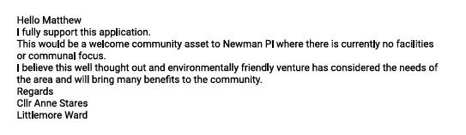
Dear Matthew Stead,

Apologies for the delay in responding to your email — I'm not sure how I missed it.

Although I understand the consultation period for Mima’s Horsebox Café on Armstrong Road, Littlemore may have closed, I still wanted to express my full support for the proposal. I believe the café would be a wonderful addition to the area and bring real benefits to the local community.

Please do keep me informed when the application is approved, as I’d love to help share the good news and support the initiative further.

Thank you for your time.

Best regards,
Cllr Tiago Corais
Oxford City Councillor for Littlemore

